Art 1 & 2: Required Art Supply List:

* **\*\*each art student will have ART DUES of $25.00 which pay for other supplies throughout the year, art T-shirt and contest entry fees**
* **This supply list is SEPARATE from the school list. These items will be kept in the art room in the students own shelf. All items are REQUIRED for art**
* **MIXED MEDIA sketchbook:** 
  + AT LEAST 60 pages
  + **\* 9 x 12, 8 x 10, or similar size**
* **Set of blending stumps**
* **2 PRISMACOLOR colorless blender pencils**
* **5 (no 2) Pencils:** 
  + **2 can be mechanical but not all**
* **Large Vinyl eraser (White eraser)**
* **1 kneaded eraser**
* **4 black Sharpie Markers:**
  + **2 Fine and 2 Ultra Fine**
* **Hand held Sharpener (with cover for shavings)**
* **2 glue sticks**
* **Pencil pouch (not a box) – optional ( I can give a ziplock bag)**
* **2 full size WHITE poster boards**

**(see pics of certain items below…sketchbook can be a different brand as long as its MIX MEDIA)**

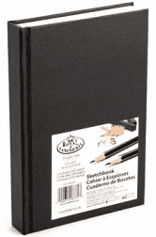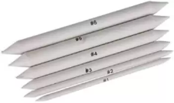Inserting image...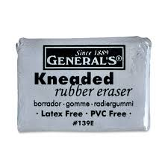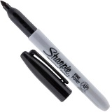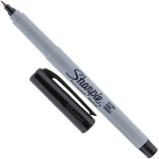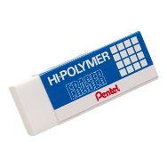

* **If you would like to donate: Tissue boxes, hand sanitizer, newspaper…..we always need these.**

**\*\*In case of financial hardship, please contact me privately & I will give you a pre-made supply packet with everything you need. You will also be exempt from dues. A PARENT must contact me via email.**

**Thank you**

**Mr. Hickerson**